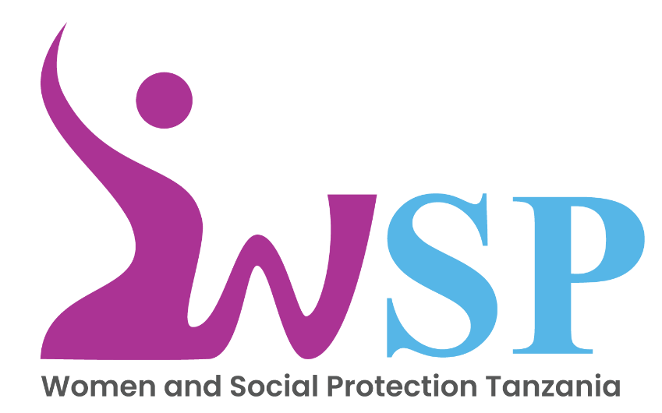

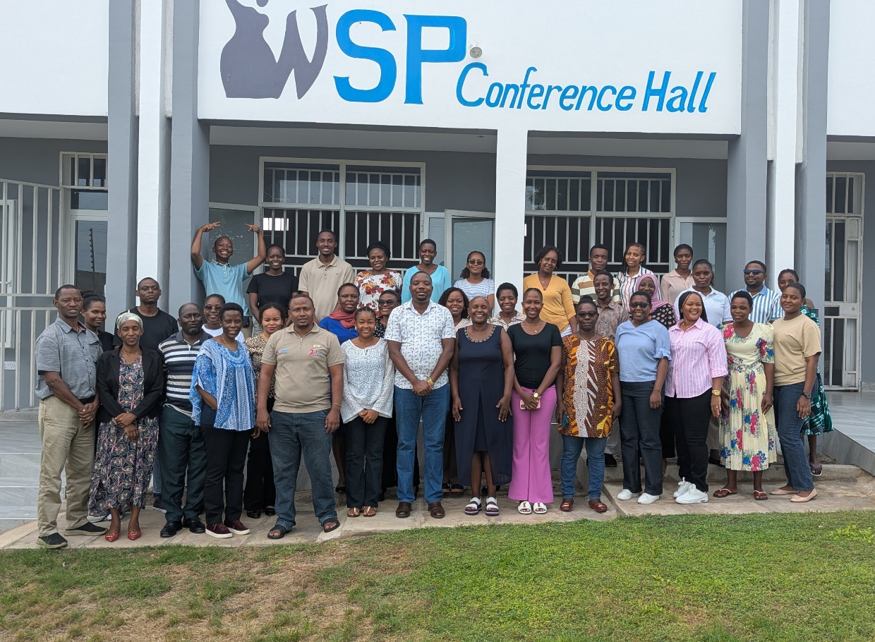
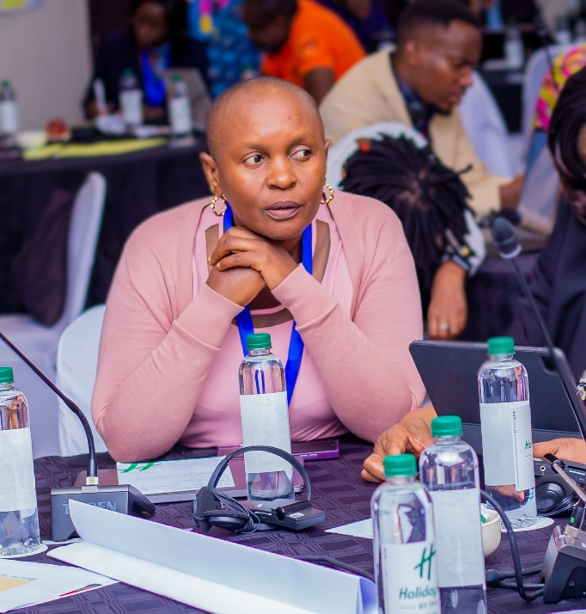
Foreword from the Executive Director – Dr Flora Myamba
Wsp annual report 2025/26
I am pleased to present this Annual Report, which highlights our key achievements, learning and progress over the past year 2025. It reflects our continued commitment to work with communities through inclusive, gender-responsive and evidence based programming.
Over the past year under the Scaling up Innovations for Reducing and Redistributing Women and Girls Unpaid Care work in Rural Tanzania, we carried out entrepreneurship and formal employment training for LGA and 14 social groups in Kishapu District. These interventions were deliberately designed to enable participants especially women those benefiting from time freed through reduced unpaid care responsibilities to pursue economic opportunities and transition into productive and dignified livelihoods.
In addition, the project started implementation of the Baba Badiliko la Jamii (BaBaJamii) which promotes shared responsibility for unpaid care work and fosters positive behavior change by actively engaging both men and women. Early results are encouraging, demonstrating improved household cooperation and increased awareness of the importance of male engagement within participating social groups.
In parallel we conducted a Poverty Persistence Study for TASAF across ten (10) districts. The insights generated will be used to strengthen and sharpen their strategies and informing program design and delivery.
We also conducted the assessment for TASAF in four districts to better understand the effectiveness and reach of Community Sessions implemented during the Conditional Cash Transfer (CCT) payment window the findings will be used for program improvements and future planning.
On strengthening systems and capacities we began preparations for the Local Government Capacity Building training. The trainings were postponed due to the 2025 Tanzanian election processes, which were later followed by security concerns. Implementation is now scheduled for 2026, as the country has stabilized and conditions are favourable for effective training delivery
I sincerely thank our donors, partners, government counterparts, community leaders, communities and our dedicated team for continued support and commitment. While this work is ongoing, we remain focused on scaling what works, strengthening partnerships and driving sustainable social change.
I invite you to explore this report as a reflection of our progress and our shared vision for the future.
1.About WSP
Women and Social Protection Tanzania (WSP) was established in September 2016 as a not-for-profit organization and was formally registered in July 2019 as a Non-Governmental Organization (NGO) in accordance with Section 8A of the NGOs Act No.24 of 2004, as amended in 2019. WSP conducts both short and long term research and training in areas of Social Protection (SP), Gender Equality (GE) and Women Economic Empowerment (WEE) with a particular focus on women and girls in Tanzania. WSP designs evidence based interventions through skills and capacity development programs and actively engages key policy makers to influence positively policy change. Through action research and tailored training targeting women, girls and policy makers, WSP generates and uses knowledge to inform sustainable solutions that improve the wellbeing of women and girls and strengthen social economic systems for sustainability.
During the reporting year, WSP strengthened these efforts by implementing key activities and engaging strategically with stakeholders.
1.1 Our Vision
“Women’s full and effective participation and decision making in social, economic and political spheres”
1.2 Our Mission
“To generate and use evidence to inform inclusive and sustainable interventions that addresses the needs of vulnerable and poor women and girls”
1.3 Our work
- Design and implement social protection policies and program with gender lens
- Research, design, implement, train, monitor, assess and evaluate policy program related to our work.
- Develop youth skills and promote male engagement in shared responsibility for unpaid care work.
- Network and partner with government, development partners and civils society organizations in what we do.

1.4 Year 2025 Key Highlights
In 2025, Women and Social Protection (WSP) progressed its work across the core pillars of Social Protection (SP), Gender Equality (GE), and Women’s Economic Empowerment (WEE) through research, capacity building, and programme implementation. Key highlights from the year include the following:
- Technical support to Tanzania Social Action Fund (TASAF) to assess factors for poverty persistence in high poverty districts despite TASAF and other poverty reduction interventions and Assessment of Community Session performance conducted during the payment window of the Conditional Cash Transfer (CCT) program.
- Provided technical support (demand driven) for the Tanzania Rural Urban Road Agency (TARURA) through International Labour Organization (ILO) to assess barriers limiting women and other vulnerable groups in community led economic activities particularly in rural road maintenance and developing and delivering training modules based on the assessment findings.
- Invited by the Government to participate in the CSW 68 in New York and had a presentation on the side event on 20th March 2025
- Implementation of the project on scaling innovations aimed at reducing and redistributing unpaid care work for women and girls in Kishapu.
- Participated in Scaling Care Innovation Workshop/conference in South Africa.
- Capacity Building for WSP team to enhance their skills on research methodologies and social protection.
- Digital technology and English language skills training to school going children.
Our funders for majority of the projects are The William and Flora Hewlett Foundation and International Development Research Center (IDRC) Canada funded study on scaling innovation on reducing and redistribution of unpaid care work for women and girls in Kishapu, Capacity Building for Local Government Authorities and TASAF provided support primarily covering travel and accommodation costs related to their projects.
2.Programs and Interventions
2.1 Understanding Poverty Persistence and Assessing TASAF Community Sessions
In 2025, WSP provided technical support to Tanzania Social Action Fund (TASAF) to assess factors contributing to poverty persistence in high poverty districts, despite ongoing interventions under TASAF and other poverty reduction programmes. The assessment was to examine the underlying factors that limit households from escaping poverty. The study was carried out in 10 districts; Longido-Arusha, Mpwapwa- Dodoma, Kibondo- Kigoma, Sumbawanga Rural – Rukwa, Nanyumbu-Mtwara, Geita Rural- Geita, Chunya-Mbeya, Mbarali-Mbeya Hai-Kilimanjaro and Mpanda- Katavi.
The specific objectives were:
- To identify socio-economic and geographic factors contributing to the persistence of high poverty levels despite development initiatives.
- To examine the effectiveness of poverty reduction interventions in selected districts
- To identify best practices and recommend strategies for poverty reduction that can be replicated in the poorest areas.
The findings from this study will provide TASAF and other development stakeholders with critical evidence to refine and strengthen their poverty reduction interventions. The insights will also inform future planning, enabling to design interventions that are more responsive to local realities and better positioned to help households sustainably escape poverty. TASAF can replicate best practices and enhance program impact in the poorest districts.
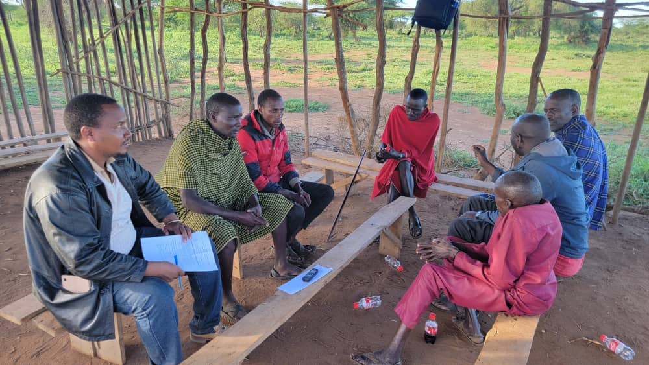
Poverty persistent assessment in Longido, WSP researcher with respondents.
WSP also worked with TASAF to carry out an assessment of Community Session performance held during the payment window of the Conditional Cash Transfer (CCT) programme under the PSSN framework. The assessment was carried out in four districts: Kinondoni, Igunga, Chamwino and Pemba. The main objective was to examine the effectiveness, coverage, and quality of community sessions conducted during CCT payment periods, with the aim of strengthening their role in promoting awareness, positive behaviour change, and compliance with programme conditions.
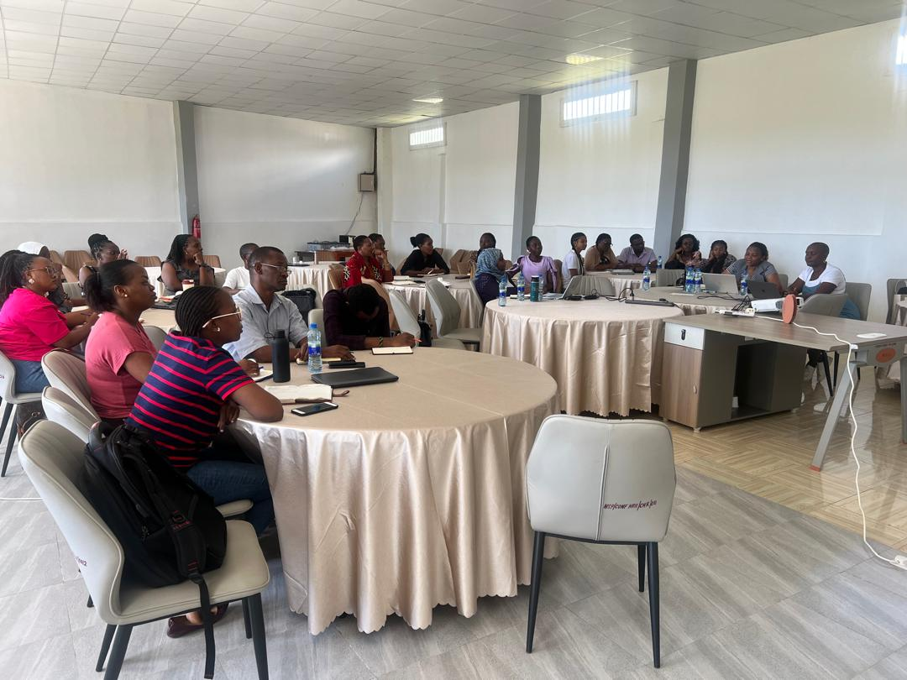
Findings from the assessment will contribute to improving the effectiveness of social and behaviour change communication (SBCC) within the PSSN framework. The results are expected to help ensure that community sessions are not a missed opportunity but rather serve as a strategic tool for translating cash transfers into long-term household capabilities. In addition, the results are expected to strengthen accountability and feedback loops between implementers and communities, while supporting the graduation and sustainability agenda by equipping beneficiaries with the knowledge and agency needed to improve their livelihoods beyond cash support.
WSP and TASAF team during a joint review of tools for the community assessment.
Through these two (2) assessments, both junior and senior researchers at WSP had the opportunity to further strengthen their research skills. Noticeable growth and increased confidence were observed across the team throughout the entire processes from data collection and data cleaning to thematic development, analysis and interpretation, report and policy brief writing.

2.2 Scaling Up Innovations for Reducing and Redistributing Women and Unpaid Care Work in Rural Tanzania, Kishapu District Shinyanga.
Women and Social Protection Tanzania (WSP) is one of the organizations implementing the project on Scaling Up Innovations for Reducing and Redistributing Women and Girls Unpaid Care Work in Rural Tanzania. The project is implemented in Kishapu District, Shinyanga Region. Other organizations are Economic and Social Research Foundation (ESRF) the lead organization and Relief to Development Society (REDESO). The project is financially funded by International Development Research Centre (IDRC) Canada.
Informed by a comprehensive baseline study conducted by ESRF, which explored the scope and impact of unpaid care work in the community.
The main goal of the project is to reduce and redistribute unpaid care work through scaling up tested innovation, addressing cultural norms, entrepreneurial and formal employment skills development for enhanced women and girls’ economic empowerment and gender equality in rural Tanzania.
The baseline study’s findings informed a dual-approach intervention led by WSP, focusing on entrepreneurship and formal job skills development alongside the transformation of gender norms. Capacity building models on entrepreneurship and formal employment were developed and the BaBaJamii module was adapted from the Bandebereho Model implemented by Rwanda Men’s Resource Centre (RWAMREC), which promotes male engagement in caregiving, challenges harmful gender norms and addresses gender-based violence. While Bandebereho primarily emphasizes on reproductive health, BaBaJamii was deliberately tailored to focus on women’s economic empowerment. The module was further contextualized to reflect Tanzanian cultural realities drawing on local norms, language and lived experiences and is delivered through trusted community facilitators to ensure relevance, acceptance and meaningful behavior change at household and later to community levels.
Prior to delivery of the models to the beneficiaries in Kishapu, a two weeks Training of Trainers (ToT) equipped 14 facilitators with technical and facilitation skills took place in Dar es Salaam. Another two-week ToT in Kishapu trained 12 Norm Change local facilitators and their partners, who tested the first the contextualized BaBaJamii training module and provided inputs which were used to produce the current version.
2.3 Roll out of trainings in Kishapu
2.3.1 Local Government Training
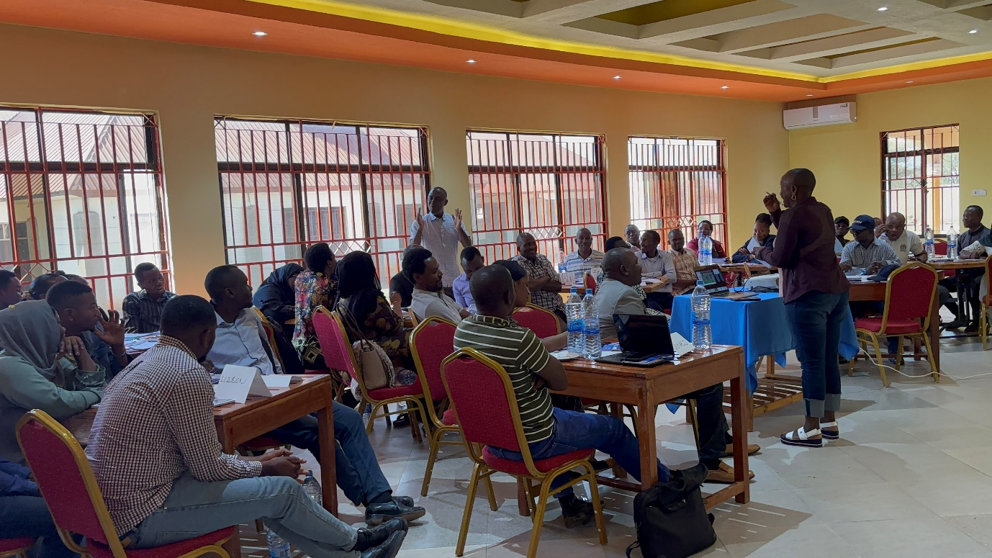
A five-day training was conducted for 40 government officials from Kishapu District Council, Shinyanga Region and relevant national level ministries on strategies to reduce and redistribute unpaid care work. The engagement was important in strengthening government ownership of the initiative with officials committing to cascade the knowledge to their communities. It also built their understanding and capacity to promote care responsive interventions, support policy uptake and enable the scaling of the intervention.
Entrepreneurship and formal jobs skills training with LGA participants
2.3.2 Entrepreneurship and formal jobs skills training
The training reached beneficiaries from 20 social groups. During the first phase 14 groups comprising 349 participants (174 men and 175 women) completed a five-day training programme per group. The curriculum combined three days of entrepreneurship training and two days focused on formal job skills.
The highly interactive sessions created opportunity for participants to share challenges, ask questions and learn from one another. The practical hands on approach enabled participants to identify viable business opportunities and available resources within their localities. As a result, participants developed business ideas, gained financial management skills, legal compliance knowledge and at the end each one produced marketing and business plans tailored to their contexts. The groups will receive the refresher training in 2026 to reinforce and sustain the skills gained. The remaining 6 groups are scheduled to receive both foundational and refresher training in 2026 to ensure consistent capacity building across all 20 social groups.
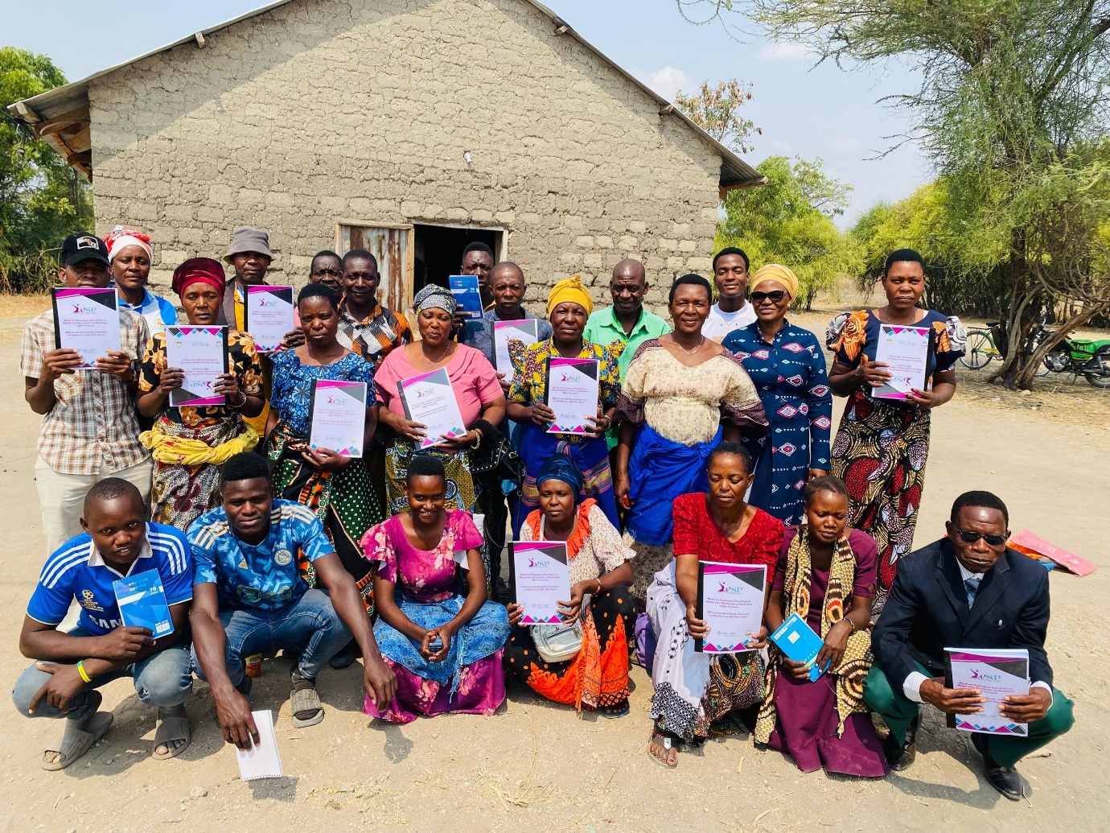
One of the social groups in Mwalata, Kishapu trained in entrepreneurship and formal employment skill
2.3.3 Male Engagement and Cultural Transformation
The intervention is implemented through the BaBaJamii programme which is central to driving cultural transformation at the household levels. It is anchored in a participatory training model that brings men and women together to jointly reflect on household dynamics and shared responsibilities. The training sessions emphasize equitable participation in income generation, joint decision making reduction and redistribution of unpaid care work. The sessions are run for 15 weeks in the first round and then there will be refresher round of another set of 15 weeks.
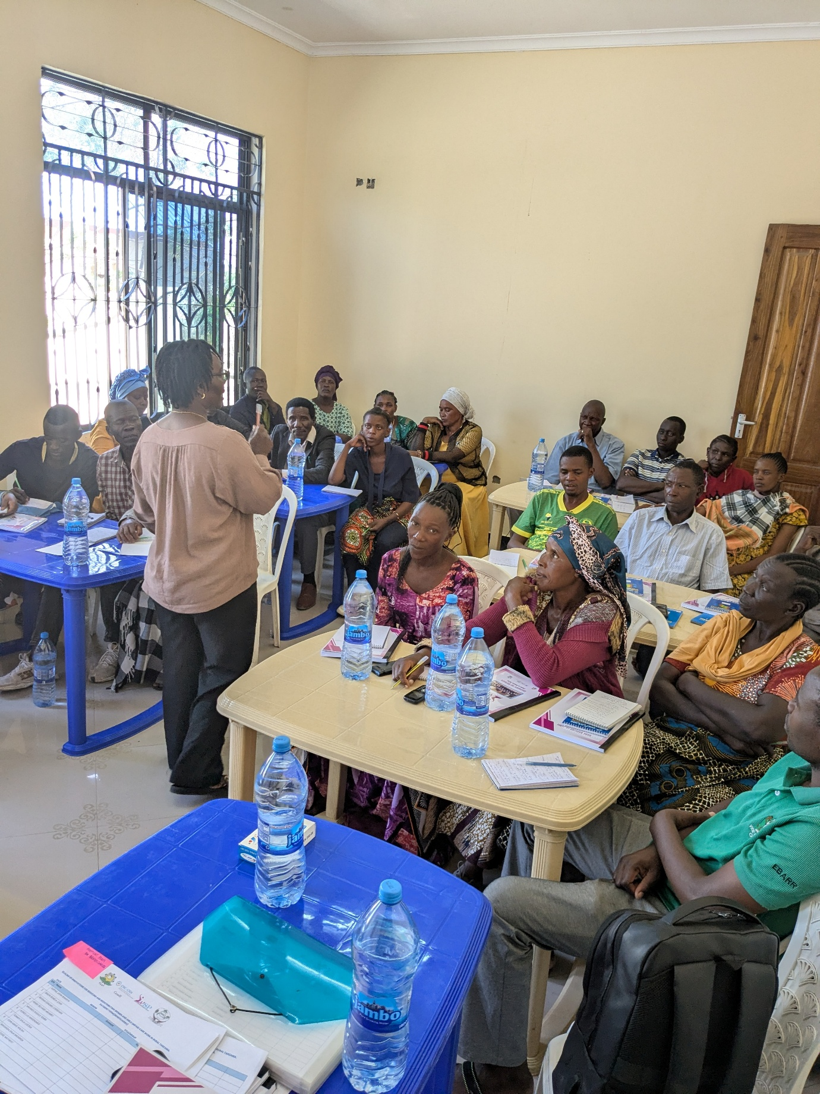
BaBaJamii training module was revised following the inputs collected from the norm change facilitator’s first round training. Following the review and changes made to the training manual and WSP conducted six day refresher training to 12 facilitators and their partners. The refresher focused on orienting the facilitators with the revised contents and strengthening their practical facilitation skills to deliver the sessions.
Refresher BaBaJamii Facilitators training in Kishapu
The training sessions were rolled out in early December 2025 to all 20 selected social groups. By mid-March 2026 all the groups have completed phase one of the training (15 weeks). Early testimonies show meaningful change; men have started assisting with childcare, household chores and farming activities.
The project demonstrates that effectively reducing unpaid care work requires an integrated approach. By concurrently addressing skills development and social norms transformation, the project has established a strong foundation for sustainable and scalable impact. Early results indicate improved relationships at the household level. As implementation progresses, sustained attention to inclusivity, participatory methodologies, and strong policy linkages will be essential to securing long-term outcomes and impact.
2.3.4 BaBaJamii Project — Kishapu Field Visit & Impact
As part of the Scaling Up Innovation for Unpaid Care Work project, WSP conducted a two-day field visit to Kishapu on February 23, in collaboration with partners ESRF, REDESO, and IDRC. The visit assessed the progress of two key project components: the BaBaJamii behaviour change initiative and the rainwater harvesting tanks programme. The team visited four community groups across four villages — Kiloleli, Kijongo, Linguya, and Muguda.
Programme Impact
Field visits provided compelling evidence of behavioral and normative shifts at both the household and community levels. The BaBaJamii RCT demonstrated high engagement during Phase One, reaching 466 of the targeted 480 participants (a 97% achievement rate). This primary target group, spanning 20 social groups, received the first phase of the male engagement intervention. Notably, participation was nearly gender-balanced, comprising 230 men and 236 women, fostering a holistic environment for social change. Participating men reported significant shifts in how they relate to their spouses and families, including reduced alcohol consumption, cessation of domestic violence, joint financial planning, and active participation in household chores and childcare. Women confirmed these changes, with one participant reporting that her husband purchased her a sewing machine and opened a shop for her to start a business.
Evelyn, representing the funder IDRC, described the outcomes as exceeding her expectations. She specifically noted the unusually rapid pace of norm change — something rarely seen in behaviour change interventions of this nature — and was particularly struck by how much women themselves had changed as a result of the programme, not just the men. She also observed that the combination of gender norm change and economic empowerment is a powerful and important pairing, with the economic benefits being especially significant in motivating and sustaining behaviour change. Evelyn further highlighted the strong sense of community identity built around the BaBaJamii name and slogan, which she noted helps participants feel less isolated and more confident in challenging existing social norms within their communities.
A key reflection from the debrief was that participants have developed a strong sense of agency — they no longer see themselves as recipients of training but as change makers capable of influencing their neighbours and communities. This led to a strategic recommendation that the next phase shift emphasis toward empowering participants to think independently and drive change themselves, rather than continuing to rely on facilitated training sessions.
Community Perception
Initial community resistance was noted, with men who participated in household chores facing ridicule from neighbours. Despite this, participants reported that visible improvements in family stability and economic wellbeing are gradually shifting community perceptions, and they expressed confidence that others would follow once they witness the results firsthand.
Prof. Fortunata Makene, Executive Director from ESRF noted that she had initially doubted whether the Bandebereho model would work for the Sukuma community but the field experience proved otherwise. She highlighted that the type of violence not often spoken about specifically how men are treated by their own fathers and how this perpetuates harmful norms across generations is an important dimension the project is beginning to surface and address.
Water Tanks Component
The rainwater harvesting tanks were identified as a highly effective complementary intervention, directly reducing the time women spend fetching water and enabling greater participation in income-generating activities. The model — which engages local artisans in construction — was praised as cost-effective and scalable, with strong potential for replication in schools and other community institutions. A key question raised in the debrief was how to ensure long-term sustainability of this model after the project ends.
Communications and Advocacy
The debrief raised a strong call to amplify BaBaJamii's results more widely. Recommendations included developing documentary content, presenting findings to parliamentarians and the Kishapu Local Council, and pursuing a spillover study to measure wider community impact beyond direct participants. There was also a strategic recommendation to engage the Ministry of Gender — with ESRF taking a visible lead in government engagement while WSP works behind the scenes, given WSP's ongoing partnership application with Equimondo for Bandebereho support.
WSP committed to two immediate next steps: delivering a refresher entrepreneurship training for all groups before transitioning to the next phase, and launching Phase Two of BaBaJamii — a 15-week programme designed to move participants from basic understanding to full behavioural competency, embedding shared domestic work and peaceful conflict resolution as permanent lifestyle changes. The project team also identified the opportunity presented by the PAMOJA initiative as a timely entry point to ensure government awareness of what has already been achieved on the ground.
Beneficiaries stories of Change
The shift in community norms is best illustrated by the testimonials of the participants themselves. Regarding the redistribution of Unpaid Care Work (UCW) and household power dynamics, participants shared the following:
"In our culture, a man who entered the kitchen was laughed at. I used to be that man who just sat and waited. Today, I fetch water and help with the children. The 'shame' has been replaced by a sense of partnership." (BaBaJamii Male Participant-Lunguya)
Additionally, the shift in decision-making, authority power dynamics: joint decisions-making and consultations has been observed which brought the power balance within the beneficiery households. This can be observed through participant testimony below:
"I believed that being a man—a real head of the house—meant my voice was the only one that mattered. I ruled with the stick and an iron heart... Everything shifted when I sat through BaBaJamii Session 9." (BaBaJamii Male Participant-Kiloleli). These testimonials underscore the program’s success in moving beyond theoretical training toward tangible, lived changes in gender equity. By addressing deep-seated cultural stigmas, the BaBaJamii intervention is successfully fostering more resilient and cooperative household units

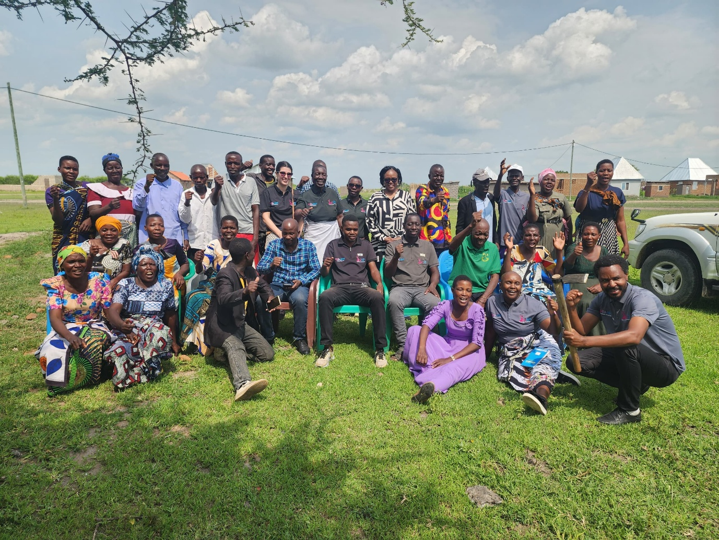
Evelyn’s visiting at Muguda along side Members from ESRF, WSP and REDESO as well as beneficiaries of the BaBaJamii program and BaBaJamii community facilitators

3.0 Gender-transformative care systems and policies through South–South peer learning.
WSP participated in the South–South Peer Learning Workshop on Gender-Transformative Care Systems and Policies held in Johannesburg. The workshop brought together over 120 policymakers and advocates from Latin America and Sub-Saharan Africa. During the convening, WSP shared experiences and lessons from the Scaling Up Innovations for Reducing and Redistributing Women’s Unpaid Care Work in Rural Tanzania initiative strengthening cross regional learning. The presentation highlighted integrated approach of combining social norms transformation, technological innovation and institutional engagement to address unpaid care work at house hold and community levels.
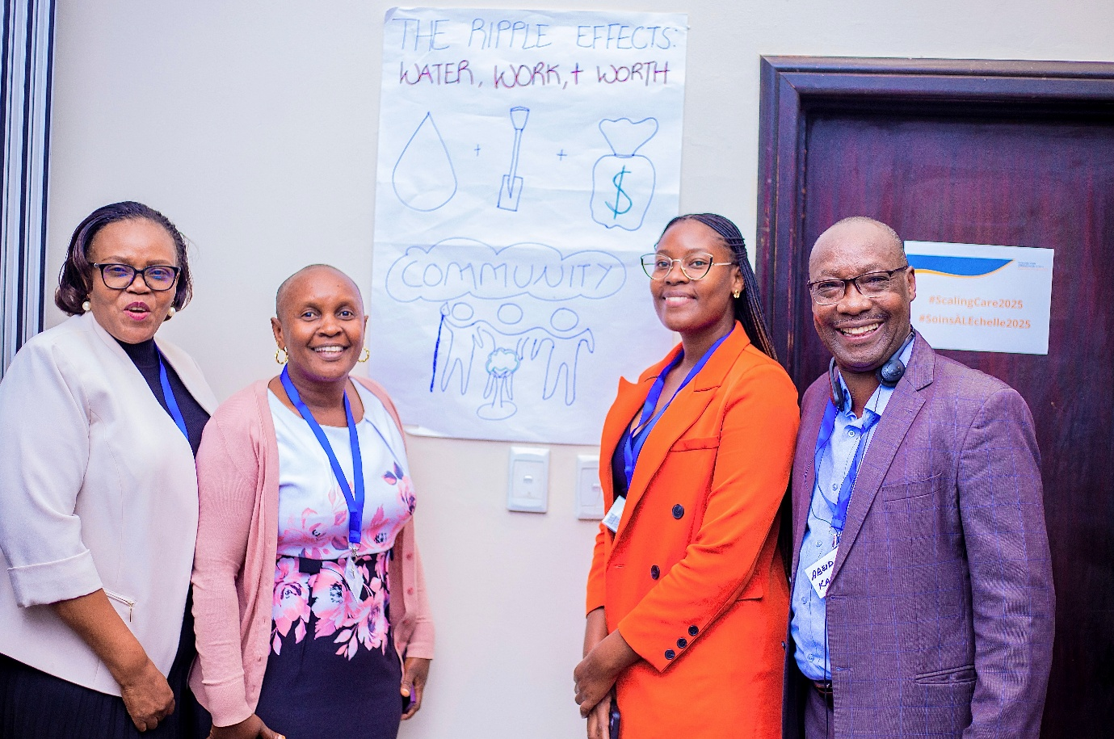
Through this engagement, WSP also gained valuable insights from other organizations on care policy reforms and implementation models. The workshop provided an opportunity to expand WSP’s professional network, strengthen strategic partnerships and positioned as an active contributor in global dialogues on gender transformative care systems.
WSP South Africa Visit
As a direct outcome of this participation, WSP was subsequently engaged by two Organizations to explore potential collaborations including joint proposal submissions. This reflect the strategic value of WSP’s presence.

4. Enhancing WSP Team Skills in Research and Social Protection
In 2025, series of both formal and informal internal training sessions were conducted aiming at strengthening the technical and strategic capacities of the team. The engagements provided a platform for skill enhancement and cross functional alignment across different teams.

During the formal training the main focus areas included research cycle covering all stages from conceptualization, methodology design, data collection, analysis, to reporting and dissemination of findings. The training also focused on social protect deepening the understanding of participants.
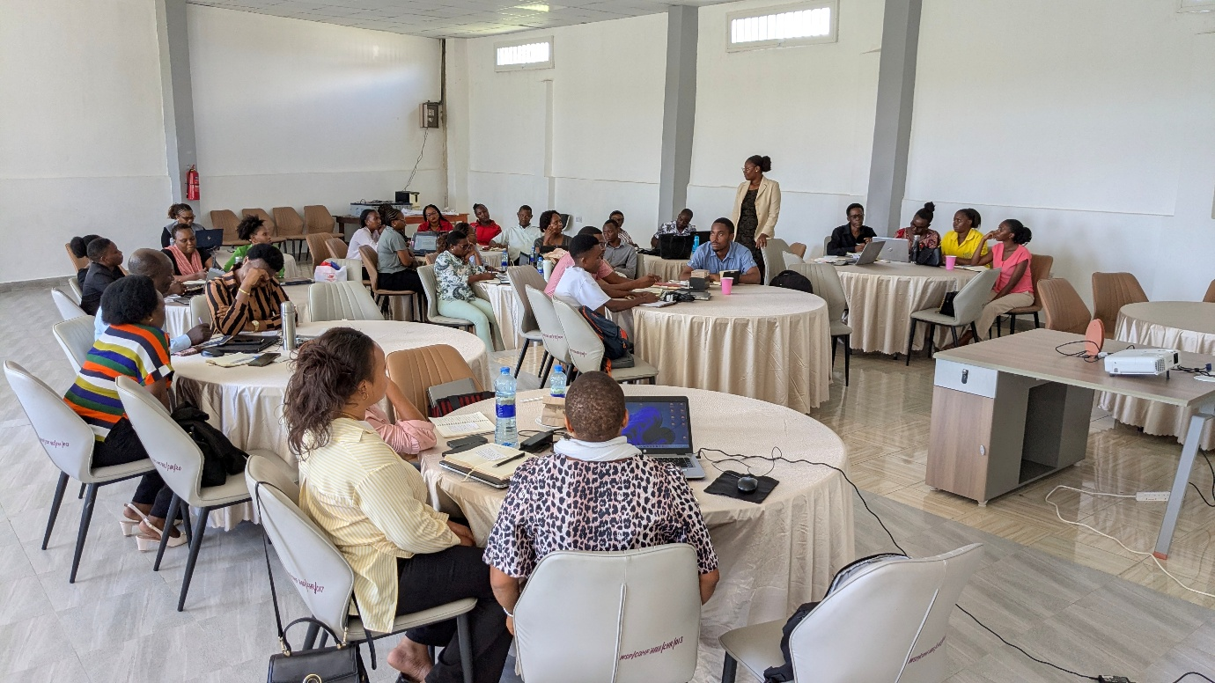
Additionally sharing project updates from different project teams created opportunities for learning, enabling the teams to deepen their technical knowledge across all WSP initiatives.
WSP Team during one of the internal capacity building sessions
4.1 Internal Capacity Building and key event(s)
4.1.1 Internal Capacity Building
In December 2025, WSP held a four-day Capacity Building and Program Review week from 16–19 December, bringing together 39 staff members and partners across research, programmes, communications, finance, and digital teams, reflecting the collaborative spirit of the engagement.
All sessions were facilitated by Dr. Flora Myamba Ph.D. (Executive Director, WSP), and were designed to elevate WSP's internal technical capabilities to meet international professional and academic standards. The training covered six core areas:
- Research Methodology — strengthening staff understanding of qualitative, quantitative, and mixed-method research designs, with emphasis on the rigorous logic required for sound field execution and data integrity.
- Research Ethics — comprehensive guidance on ethical considerations in fieldwork, including informed consent, respondent confidentiality, and the "do no harm" principle.
- Professional Report Writing — practical instruction on formatting and structuring WSP deliverables to meet donor compliance requirements and academic standards.
- Budgeting and Financial Management — equipping staff with skills to create, manage, and align project budgets with institutional goals and fiscal responsibility.
- Monitoring and Evaluation (M&E) — introducing frameworks for tracking project progress, measuring impact, and applying data-driven insights to improve programme implementation.
- Social Protection Theory and Local Application — a dedicated module defining the four functions of social protection (protective, preventive, promotive, and transformative) and examining their application within the Tanzanian context, including a comparison of mainland and Zanzibar approaches and programmes such as TASAF-PSSN and the Zanzibar Universal Social Pension (ZUPS).
Beyond the technical training, the week also functioned as an organisational transparency and alignment platform, with each project team presenting their progress and achievements to the full organisation. This cross-functional review covered the LGA Capacity Strengthening, TARURA Morogoro, Unpaid Care, TASAF/PSSN Policy Briefs, and Digital Kids programmes ensuring every staff member had a clear understanding of the status, accomplishments, and upcoming phases of WSP's work.
The week concluded with provision of formal certificate ceremony recognising staff who had successfully completed the July 2025 training modules on Entrepreneurship, Job Training, Norm Change, and the BaBaJamii Training of Trainers (ToT) facilitation programme, marking the close of the organisational calendar and strengthening team cohesion heading into 2026.
4.1.2 Key event: Commemorating International Women’s Day 2026
On March 9th, Women and Social Protection Tanzania (WSP) marked International Women’s Day under the theme “From Unpaid Care to Economic Power: Rights, Justice and Action with WSP.” The celebration provided a powerful platform to reflect on the disproportionate burden of unpaid care work carried by women and to explore practical strategies for advancing economic empowerment.
The event highlighted progress from the BaBaJamii intervention in Kishapu, where men are increasingly engaging in caregiving roles such as cooking, cleaning, fetching water, and childcare. These behavioral shifts are fostering more equitable households, enabling women to participate in income-generating activities and decision-making processes. Testimonies shared during the event confirmed that these changes are improving family wellbeing and gradually redistributing unpaid care responsibilities.
The day also brought together WSP staff and parents whose children benefit from the Digital Kids Program. Parents expressed appreciation for the English and computer training provided, noting improvements in their children’s academic performance and safety. They also voiced aspirations for their own empowerment, requesting digital literacy training and access to small capital to strengthen their livelihoods.
Group discussions during the event generated actionable ideas for reducing unpaid care burdens, including:
• Integrating unpaid care into national policies and social protection frameworks.
• Introducing labor-saving technologies such as improved cooking stoves and affordable childcare services.
• Connecting women to funding opportunities, markets, and mentors.
• Building women’s leadership skills, particularly in agriculture.
The event reaffirmed WSP’s commitment to tackling unpaid care work as a cornerstone of women’s empowerment, while also underscoring the importance of scaling interventions like BaBaJamii and complementing them with new initiatives. Additionally, It also showcased WSP’s role in driving behavior change, strengthening family dynamics, and creating pathways for women’s economic power.

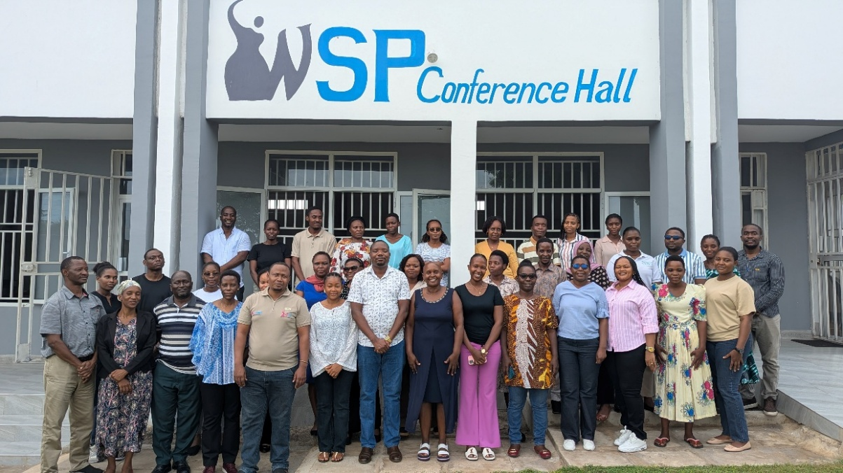
WSP Members and DDO Members after December 2025 Training Group Photo

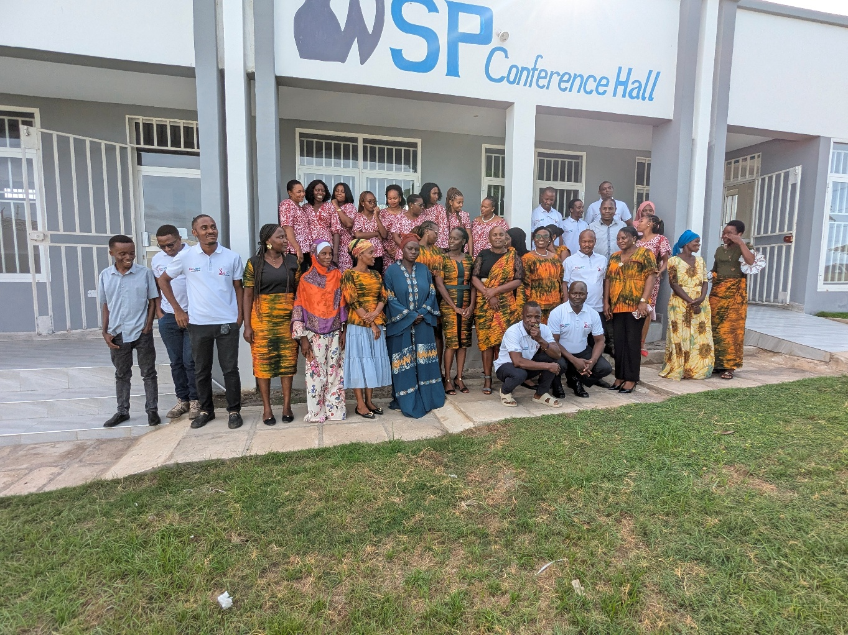
international womens day 2026

